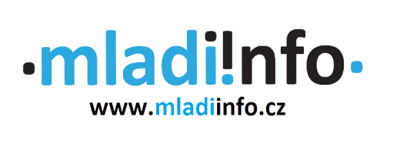

European Solidarity Corps Project Application Form

Name of the project: Promoting solidarity in Brno - Mladiinfo ČR

Date: 1st of August 2020 – 31st of March 2021

Contact person: Eliška Motyčková
E-mail: kancelar@mladiinfo.cz

Please note:

- Your application must be filled in English.
- All questions are obligatory.
- When sending us your filled application, please attach also one picture of yourself where you feel happy and comfortable.
- Incomplete application will not be considered.
- By submitting this application, you give is the right to process your personal information.
- Please, submit this application as PDF file or Microsoft Word document only

Personal information
Name:
Surname:
Age:
Gender: | ☐ Male  ☐ Female  ☐ Prefer not to say
Nationality and country where you live:
Your e-mail:
Phone number:
Skype:
Your Background
Current occupation:
What is the level of your English?
Have you ever participated in European Voluntary Service or European Solidarity Corps? | ☐ Yes  ☐ No
Have you ever volunteered somewhere? Please specify. (max 100 words)
What is your educational background?
(max 50 words)
Have you ever participated in Erasmus+? (youth exchanges, mobilities of youth workers, university study abroad). Please specify. (max 100 words)
Do you have any special needs? (e.g. disability, health or social obstacles, etc.). If yes, please tell us how we can help you to make you feel comfortable during your volunteering.
Do you have a driving license?
Motivation
Why are you interested in our project specifically?
What would you like to gain from volunteering, what would you like to learn, and what dreams do you have for your professional future after the volunteer programme?
What will the project get from selecting you as their volunteer?
How should an ideal day of a volunteer look like?
Your Commitment
How much do you know about volunteering through ESC and from where? (max 100 words)
Would you be willing to promote the project during your stay? (e.g. articles on www.mladiinfo.cz, YouTube videos, social medias etc). Please specify: (max 100 words)
Would you be willing to promote the project after the stay in the Czech Republic? (e.g. lectures, social events in your country). Please specify: (max 100 words)

By submitting this application, you give your consent to processing of your personal data. Personal data processing is regulated by national law of the Czech Republic. The consent is granted to Mladiinfo CR, z.s. as the data controller for the purposes of the selection procedure for the given job and further for the purposes of registration of you as a potential volunteer of the organization.

Please, don’t be worried to be honest with us. We will not judge or disqualify you from the application process based on your special needs. We just need to know how to help you.

