

**ESC IN WALES, United Kingdom**

##### Cae Tan

##### *Community supported agriculture*

**__________________________________________________________________**

**Host project**

[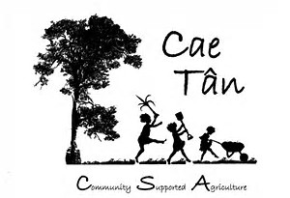](https://www.bing.com/images/search?view=detailV2&ccid=ll1E9Lga&id=1F2EFA70CF047F5A9E1CF0C716EBF6ABA475250A&thid=OIP.ll1E9LgaQ9GW3WiZ5Yfo2wEsDQ&q=cae+tan&simid=608008220961998871&selectedIndex=0)Cae Tan CSA grow organic vegetables for over 100 local households. We are based on the beautiful Gower peninsula in South Wales. As Wales largest community supported agriculture (CSA) project, we share responsibility, rewards & risk with our members in growing our food. We run educational activities with local schools, families & community groups. We host a trainee each year from within the UK who will work alongside our ESC volunteer. We have a small committed group of growers & volunteers & the support of six directors. To find out more have a look at our website & the short film there. [www.caetancsa.org](http://www.caetancsa.org)

**Project outline**

[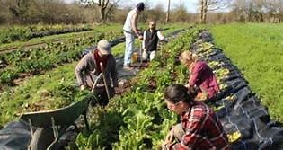](https://www.bing.com/images/search?view=detailV2&ccid=Sipw1p45&id=5DAA67F3E73531D6F010DE75F328216772BFEE1B&thid=OIP.Sipw1p45dO-rqY60kYrAZQF1Cn&q=cae+tan&simid=608005124331340636&selectedIndex=52)The majority of work will take place at our main site, which is a small field in the heart of The Gower Peninsula. It is fairly close to a local population & walking distance from Three Cliffs Bay, one of the best beaches in Wales. The field has the feeling of privacy & wilderness as ancient oak trees surround it. We have another field where we grow our winter crops which is based on the north side of the peninsula overlooking the Loughor estuary.

On a weekly basis we transport all of our produce to a hub at the Gower Heritage Centre, where we have a packing shed & meeting space. This is our chance to meet our members on a weekly basis & have a social whilst they collect their produce.

Day to day work is sociable as we have a good team of staff & regular volunteers. The Gower Peninsula is a beautiful location, where people are very welcoming. There’s always lots going on in the way of events & social gatherings.

[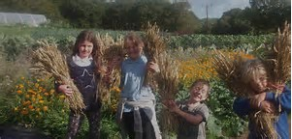](https://www.bing.com/images/search?view=detailV2&ccid=IwWvgPOn&id=B97246A49D690ECEFDC8F60EC6007736197E640F&thid=OIP.IwWvgPOn9j5bTuXDD7ADuAEsCQ&q=cae+tan&simid=608006322600673587&selectedIndex=60)The ESC volunteer would work alongside our growers & trainee grower on the main site, second field & at the Gower Heritage centre Hub. They would be involved in all aspects of the CSA, which incorporate the following;

• Seed sowing, ground preparation, planting, pest management, harvesting.

• Maintenance of structures, fencing, construction of polytunnel etc.

• Packing & hosting the hub where produce is collected

• Assisting in educational activities, such as school visits

The ESC volunteer will always be working alongside others. There may be a few occasions where they work alone for short periods.

There is potential for a volunteer to develop his or her own project.

The volunteer will have the daily support of both the main & the second grower. They will also meet all of the directors who can act as back up support. The main grower will manage their daily routine & work plan. The volunteer will be treated as a trainee & as such each task will be explained & supported. It is up to the trainee to ask for further support in areas they are particularly interested to learn more about. The volunteer will work 32 hours a week & occasionally be responsible for watering polytunnel crops at the weekend.

**Required skills**

[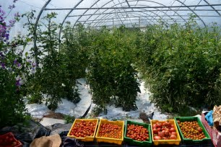](https://www.bing.com/images/search?view=detailV2&ccid=2bH8JFN3&id=ADB05C4F17ECB627015BF2DC1F1F377F376A2EA7&thid=OIP.2bH8JFN3nWcIvvdZf4_nTQEyDM&q=cae+tan&simid=608052115518653466&selectedIndex=25)Cae Tan is looking for volunteers with an interest in agriculture and community growing. Experience of working on a farm may be useful but is not our foremost criteria. The projects hosted by Cae Tan are open to all young people, regardless of background, competences and experience.

The projects hosted by Cae Tan is open to all young people aged 18 – 30, regardless of background, competences and experience. Volunteers ideally will:

* Have an interest in agriculture and community growing
* Have experienced work with and/ or have an interest in working in a community based agriculture scheme
* Have a good level of English and a commitment to improving their English (to be able to get the most from the placement)
* Be flexible and adaptable to change
* Be reliable
* Have a willingness to develop projects and pieces of work according to interests.

**Practical conditions**

ESC volunteers will be staying in accommodation at the Gower Heritage Centre in Parkmill or hosted at one of our members houses. Either way they will be based in a sociable environment close to the coast & a 30 minute bus ride from the centre of town.

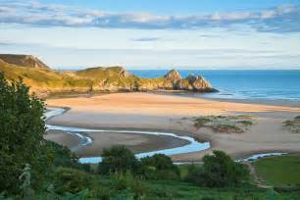You will receive your allowance for food and pocket money into your UK bank account once it is set up.

**Things you should know**

Whilst the project is in a rural area, we are close to a town (Swansea). There are good bus links both into town & further out onto the peninsula (but only certain times a day). Your accommodation will be shared with our UK trainee.

**Application Process**

Whilst Cae Tan is the actual host of this project, UNA Exchange is the coordinating organisation and administrating the whole project. Hence, you will apply for this project with Cae Tan through UNA Exchange.

Please read carefully through the description, consider to go online as well to find more information about Cae Tan (www.caetancsa.org). The project will start on 1st March 2020 – 30th November 2020 (9 months). Please make sure you are available to dedicate this time period to volunteering in Wales.

**To apply for this project please complete this application form and send it together with a copy of your CV and a motivation letter to evscoordinator@unaexchange.org (please copy your sending organisation into the email). Application deadline is the 15th January 2020.**

Please use the following in your email subject: “your name” :: Cae Tan

EUROPEAN SOLIDARITY CORPS

**Application form**

# *UNA Exchange Programmes Manager – Vicky Court*

Temple of Peace, Cathays Park, Cardiff CF10 3AP, Wales UK

Tel: 00 44 29 2022 3088 E-mail: [evscoordinator@unaexchange.org](mailto:evscoordinator@unaexchange.org)

**Your Sending Organisation**:

Phone:

Fax:

Email:

Address:

**Contact Person:**

**PROJECT TITLE: Stackpole National Trust -Events and Marketing Assistant Role**

***Please answer all questions, giving as much information as possible; it will really help in your application***

First name/s: Male ❒ Female ❒

Family name/s:

Date of Birth:

Current Address

Street and number:

Postcode:

City:

Country:

Tel:

Mobile:

E-mail:

Skype:

When is the best time to telephone you?

Emergency contact details in home country (Name, Relationship to you, Email Address and Telephone number):

Do you have additional needs that would need to be taken into account: dietary needs, problems of mobility, health care? (Please be as honest as possible so that we are able to support you properly whilst on your project and match you to a project that best suits you)

**GENERAL INFORMATION**

What are you doing at the moment? Are you working, studying, volunteering or unemployed?

Please tell us about your past work or studies: subjects, training, jobs:

Please tell us about any volunteering you have done:

What do you like to do in your free time?

Please summarise any travel experiences:

Please summarise what experience you have of living away from home/ by yourself:

Which languages do you speak and how well?:

*Native/fluent:*

*Good:*

*Medium-Good*:

*Basic:*

**PROJECT INFORMATION**

Please describe your motivation for participating in European Voluntary Service.

What are your expectations, what do you hope to gain from it and what does being an ESC volunteer mean to you?

What kind of challenges/difficulties do you think you will face on this ESC project in Wales?

Describe how you think you will react to being in a foreign country and with a different culture for 9 months.

How would you react to living in a shared house where another housemate is very messy/ untidy?

How would you feel about being based in a very remote and isolated area of Wales with very little public transport links?

Why are you interested in **this particular project**?

What relevant experiences or skills do you think that you can ‘confidently’ contribute and what do you think the host is expecting from you?

Describe your experience of marketing and business development?

What would you like to learn whilst you are here? Which skills/ knowledge would you like to develop?

Is there anything else you would like to add?

**Please be aware that if you are accepted you will be required to present a Certificate of Good Conduct from your host country (your sending organisation will know about this). You will then have to undertake a British criminal records check. Are you happy with this?**

**Y / N**

**Declaration**

**‘I declare that all of the information on this application form is honest and truthful to ability, experience and support needs and has been completed by the volunteer named on this application’** ❒please tick here to show you understand and accept the above declaration.

**Thank you for completing this application form – please email or send it to the details given at the top of the form and we will respond to you as soon as we have made a decision.**

**Vicky Court – Programmes Manager UNA Exchange**